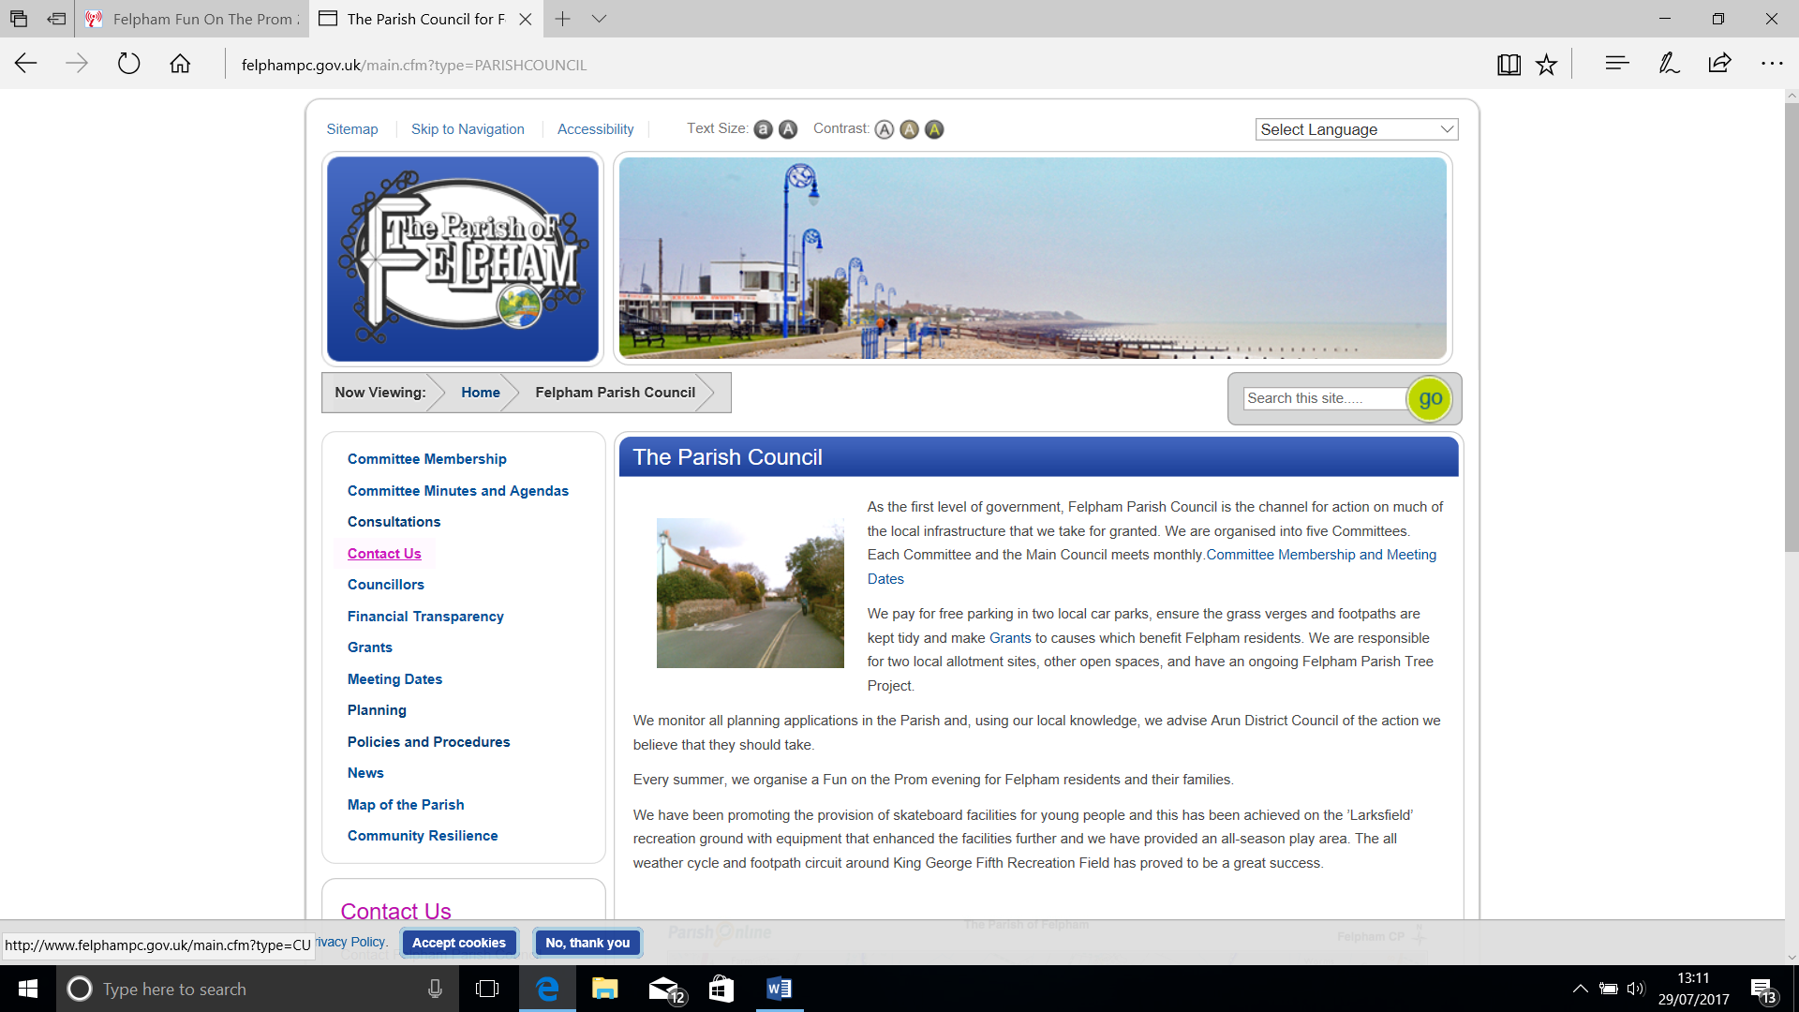

**FELPHAM PARISH COUNCIL**

**DISCRETIONARY GRANT APPLICATION**

|  |
| --- |
| **Please ensure you have read and understand all the information, terms and conditions contained within this application.** |

The purpose of this pack is to help you understand and comply with the process of applying to Felpham Parish Council for a Discretionary Grant. Please read the notes before completing the application form. All questions must be answered, providing enough detail to enable the Council to make a sound and fair decision. It is in your interests to provide as much detail as possible.

Applications cannot be considered from organisations which;

* Support or oppose political parties
* Discriminate on the grounds of age, sex, disability, race, religion and belief or sexual orientation or
* Where Central Government, Health Authorities, County or District Councils are the statutory funder for the equipment or service for which the bid is being made. However, schools for example, may wish to bid for something that is not supplied through state funding.

**REQUIREMENTS AND CONDITIONS FOR AWARDING GRANTS**

Any organisation, club or society that wishes to make an application for grant aid must;

* demonstrate that the project justifies a grant application
* submit a fully completed application form (forms received after the closing date will not be considered)
* agree to provide receipts for transactions made with the grant to the Parish within 28 days if requested
* agree to acknowledge the contribution made by the Council in all publicity associated with the project
* be aware that all recipients of Parish Council grants may be subject to a visit by a small group of Councillors to see how the grant has been spent
* be aware that provision of a grant does not authorise the activity to be undertaken. The applicant is responsible for all legal permissions and insurances
* be aware that the Council will pursue repayment of the grant and costs if any criteria have not been adhered to.

|  |  |
| --- | --- |
| **ORGANISATION DETAILS** | |
| Name of Organisation |  |
| Purpose of Organisation |  |
| Date founded |  |
| Charity registration number (*if you are a charity)* |  |
| Registered address of the organisation (or branch making the application) |  |
| Name and address of the person applying |  |
| Position in organisation |  |
| Contact details | Tel:  Mob:  Email: |
| Amount your organisation is applying for |  |
| Date application submitted |  |
| OVERVIEW OF THE PROJECT | |
|  | |
|  | |
|  | |
|  | |
|  | |
|  | |
|  | |
|  | |
|  | |
|  | |
|  | |

**You must answer all the following questions;**

**(*Please use additional sheets if required*)**

|  |  |  |
| --- | --- | --- |
|  | **QUESTION** | **RESPONSE** |
| 1 | Purpose of the grant. Please give full details. |  |
| 2 | Total cost of the project and what proportion of the total project this grant will form.  (*Please attach copies of estimates*)  **Note:** You will need to demonstrate your grant is proportionate to the number of Felpham residents who will benefit directly from the project. |  |
| 3 | How will you fund the remainder of the project? |  |
| 4 | Give details of the target group.  Please indicate the overall number of people and also specifically the number of Felpham residents who will benefit from this project? |  |
| 5 | Please indicate whether this is a permanent project that will benefit the residents of Felpham for many years or whether there is a time limit. If there is a time limit what is it and why? |  |

|  |  |  |
| --- | --- | --- |
|  | **QUESTION** | **RESPONSE** |
| 6 | Recognising that any grant must be spent within 12 months please outline the timeline for the project to be completed? |  |
| 7 | What procedures do you have in place to ensure that the grant will be ring fenced for the stated purpose? |  |
| 8 | We may seek proof that any grant has been used for the purposes intended. Please outline how you would provide that proof? |  |
| 9 | Please explain how you intend to measure the success of the project. |  |
| 10 | Have you received grant aid from Felpham PC before?  *(Please give details and amounts.)* |  |

Felpham Parish Council in considering any application will also measure such application against the following 4 guiding principles. Any scheme or project for which a grant is considered must:

1) Support the lifestyle of local people,

2) Support a active and healthy lifestyle and

3) Be beneficial to the local economy and culture

4) Bring people together

Please indicate which of the following your scheme/project supports (*tick all that apply*)

|  |  |  |  |
| --- | --- | --- | --- |
| **1) Support the lifestyle of local people,** | | | |
| Providing opportunities for a diverse range of experiences |  | Developing skills |  |
| Improving physical wellbeing |  | Improving emotional wellbeing |  |
| **2) Support a active and healthy lifestyle and** | | | |
| Providing opportunities for a diverse range of experiences |  | Developing skills |  |
| Improving wellbeing |  | Supporting independence |  |
| **3) Be beneficial to the local economy and culture** | | | |
| Protecting the environment and promoting sustainable development |  | Raising the profile of the local community and encouraging new visitors |  |
| Supporting the development of skills and knowledge |  | Assisting start-up of new community groups and businesses |  |
| **4) Bringing people together** | | | |
| Organising community events and activities |  | Increasing group membership and widening participation |  |
| Starting up new activities and expanding existing services for members of the community |  | Making local communities more resilient |  |

|  |
| --- |
| **DOES YOUR ORGANISATION HAVE CONSTITUTION OR MISSION STATEMENT?**  **IF SO PLEASE ATTACH A COPY TO YOUR APPLICATION.** |

**In support of your application please attach a signed statement of accounts for the last complete year. This must include details of any reserves or other holdings that your organisation can access.**

Please include any other supporting documents you may wish to send. (Please do not send original documents, as the Council does not accept any responsibility for the security of original documents.)

**Signed & Dated applications should be returned to:**

**The Clerk**

**Felpham Parish Council**

**Felpham Community Hall**

**Meaden Way**

**Felpham**

**West Sussex**

**PO22 8FA**

The Council will convene to make decisions quarterly and applicants will be advised as to the outcome of their application. Successful applicants may be invited to attend the Parish Council formal Grants Award evening to receive their cheque and to say a few words about the project.

**TERMS AND CONDITIONS;**

The Parish Council is under a duty to protect the public funds it administers. It may use the information you have provided on the application form for the prevention and detection of fraud. The Council also reserves the right, as part of its decision making process to carry out such due diligence checks as necessary to ensure the validity and accuracy of any application. It may also share this information with other bodies responsible for auditing or administering public funds for these purposes.

|  |  |  |
| --- | --- | --- |
| **Terms and Conditions** | | **Tick** |
| 1 | The funding must be used only for the purpose specified in the application. |  |
| 2 | The money must be used within 12 calendar months of the allocation being received unless otherwise agreed prior to the funding award. |  |
| 3 | The organisation must if requested by the Parish Council provide evidence that the grant money is/has been spent specifically for the purposes of the original application. |  |
| 4 | At the end of the project or in the case where an organisation ceases to exist, or if an organisation ceases to provide a service in the area, the organisation shall notify the Council and if so requested, return any equipment or unspent grant. |  |
| 5 | Felpham Parish Council accept no liability whatsoever in respect of any complaints, claims or actions arising from or associated with any community project. |  |
| 6 | The applicant will be responsible for the expenditure of the monies allocated under this scheme and shall provide all required information to Felpham Parish Council. |  |
| 7 | If through multiple applications the organisation receives more money than required to complete the project, they may be asked to return a pro rata amount to the Council |  |

**DECLARATION: On behalf of the applicant organisation, I declare that**:

I am authorised to make this application. I have read, understood and completed the application in line with the information contained in this form. All the information and supporting documentation I have provided is truthful and accurate.

I declare that if a grant is awarded, that the money will be used solely for the purposes outlined in this application and that proof of this will be returned to the Council for monitoring purposes. If details of the project or service change, I will notify the Council, which reserves the right to have the grant aid returned.

**Data Protection:** Felpham Parish Council (the Controller) will store your contact details on a secure database until the end of the grant period. The information will not be shared unless the law permits. The Council reports funding decisions and these are published on our website, along with all applicant organisations’ names, the decision on the bid, the grant amount awarded and a brief project description.

Signature………………….…………………. Date……………………………...

**Your signature confirms that you have read and agree to all of the terms and conditions.**